Student’s name | …………………………………………………….…… | Grade | 5
Subject | Computer | Week No. | 7
Lesson Title | Smart Art, Hyperlinks in PPT | Unit
Worksheet No. ( 7 )
Question A: Fill in the blanks with the words in the box below.

Slides Tab | Slides Pane | Notes pane & view area

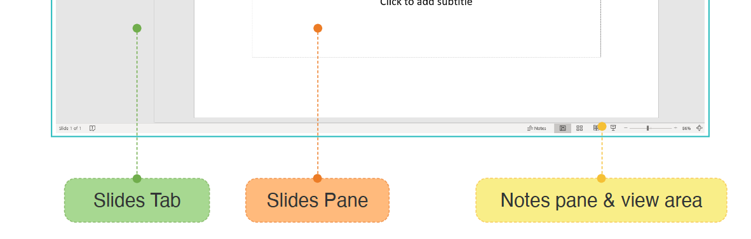
…………………
…………………
…………………
Good Luck

